Geography Learning in School and at Home
Websites for children
Here are some useful websites to use with your child at home to support their learning in geography.
www.bbc.co.uk/bitesize/primary
www.natgeokids.com/
www.playgeography.com/

Using Maps and Globes
Using and understanding maps is an integral part of learning in geography. These are the atlases that we use in school as part of our geography lessons. The maps are colourful and fun, and the text is accessible for children.
KS2 KS2 EYFS and KS1
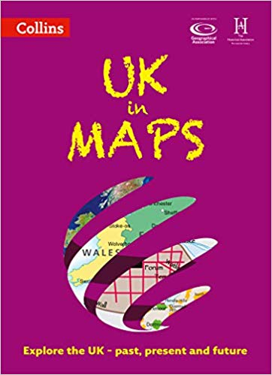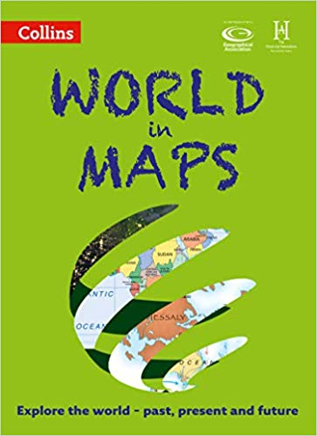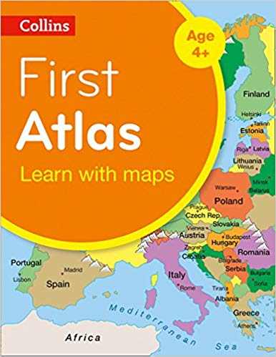

We also use inflatable globes in school. Traditional globes are usually breakable and expensive. Infalable globes are a great resource to use with children as they are cheap to buy, difficult to break and are lots of fun! These are available to buy online.
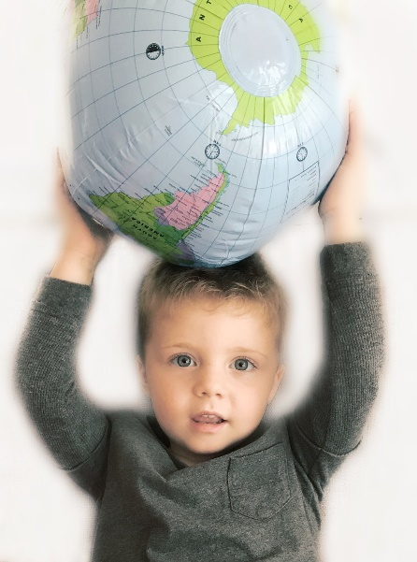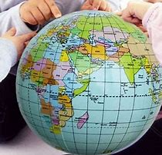
Stories and Reading
There are lots of wonderful stories and information books that can support your child’s learning in geography. Here are just a few…
Reception and KS1
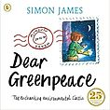 Dear Greenpeace by Simon James.
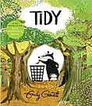 Tidy by Emily Gravett
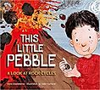 This Little Pebble by Anna Claybourne & Sally Garland
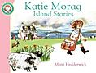 Katie Morag Island Stories by Mairi Hedderwick
KS2
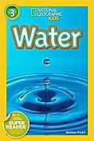 Water by Melissa Steuart
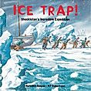 Ice Trap! Shackleton's Incredible Expedition by Hooper and Robertson
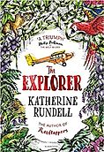 The Explorer by Katherine Rundell

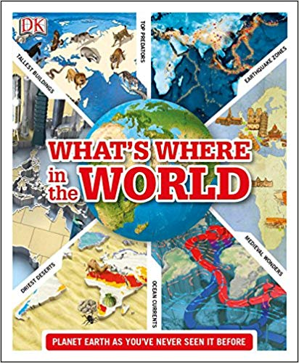 What’s Where in the World by DK

